Grade 7 Accelerated · Unit 3 · Lesson 2  Quotient Laws of Exponents  Independent Set 3.02 ANSWER KEY | Name  Date  Period

Six questions, on your own, in silence. Show the step that does the work.
1. Write as one power. 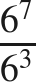


2. Find the value. 


3. Find the value. 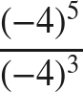

An even power of a negative base is positive.

4. Rewrite so the exponent is on the numerator and on the denominator. 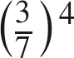


5. Find the value. 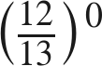
1
Any nonzero base to the zero power is 1.

6. Find the value of . 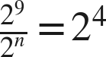
n = 5
9 − n = 4.

